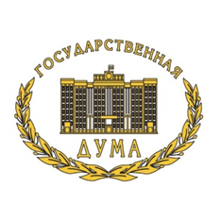 | ASIAN PARLIAMENTARY ASSEMBLY  APA Standing Committee on Economic and Sustainable Development meeting  Naryan-Mar, Russian Federation  18-21 April 2019 | 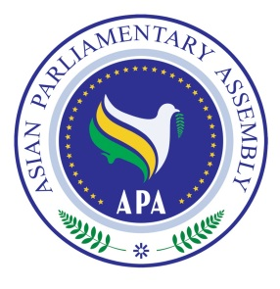

REGISTRATION FORM
Please fill in one form for each participating delegate in CAPITAL letters, and return by 10 March 2019
Passport copy attachment is obligatory.

Delegation of: … ………………………………..…
Name of Parliament

Title: Mr. Ms. Dr.
First Name:
Last Name:

Position: ……………………………………….. Head of delegation Member of delegation
- Please indicate if you are the Head of delegation
Passport No: Date of birth (d/m/y) Place of birth (City, Country)

.. ………………………..…

Passport issue date: Passport expiry date: Place of visa issuance (City, Country)

……………………………….

Tel No. | …………………..  Country Code - City Code - Number
Mobile No.
Fax No.
Email Address:
Flight Details

 | Date | Airline & Flight number | Time | Explanation
Arrival
Departure
Please forward (fax or e-mail) the completed form to both the Host Secretariat as well as CC to the APA Secretariat:

Host Secretariat:
Email: APARussia@mail.ru
CC to APA Secretariat:
Email : secretariat@asianparliament.org
Fax : (+98-21) 33517408
Phone : (+98-21) 33517406
33517407

okarizhskaya@adm-nao.ru
Fax : (+7) 495 692 53 58

ASIAN PARLIAMENTARY ASSEMBLY

APA Standing Committee on Economic and Sustainable Development meeting
Naryan-Mar, Russian Federation

18-21 April 2019

To Facilitate our preparations to issue the identification Badges please complete and return this form together with the Registration Form and Passport copies

DELEGATION OF ……………………………(Parliament), ……………………(Country)

No. | First Name | Last Name | Name of Badge | Position | Photo
1
2
3

